HALF ADDER

AIM: TO implement the half adder using logic sim

INPUT:

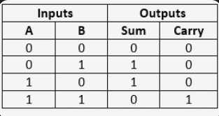

OUTPUT:

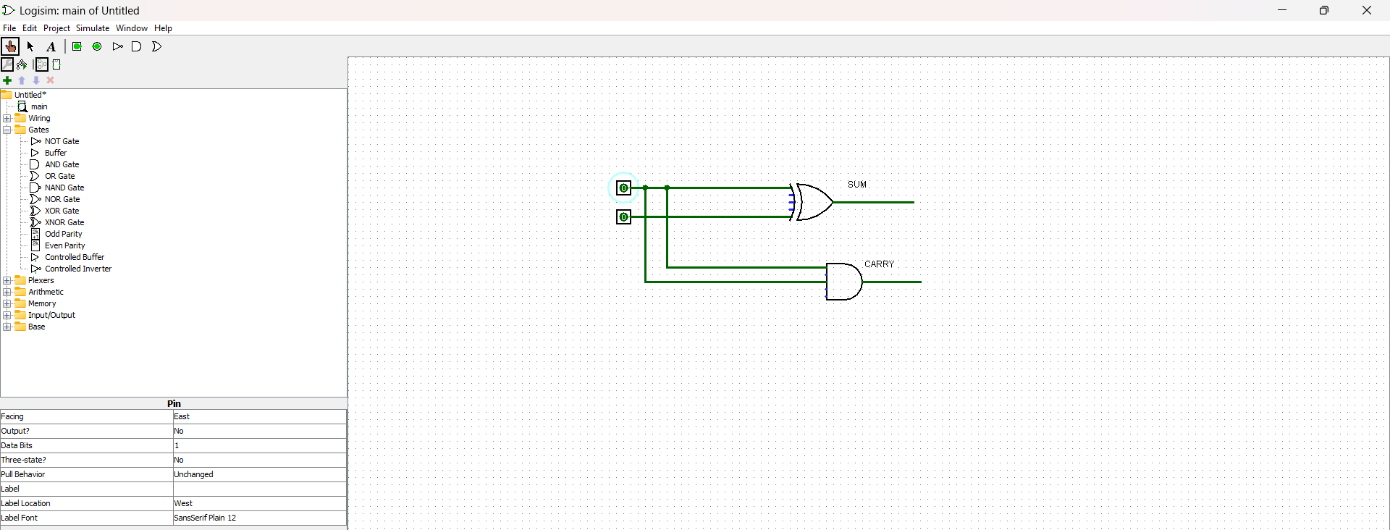

RESULT: Thus the program was executed successfully using logic sim